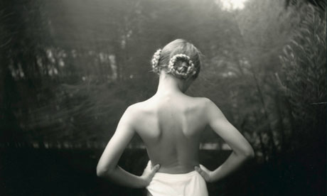
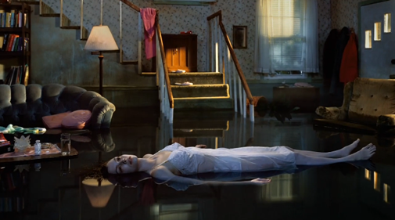
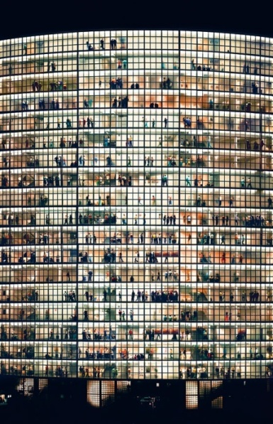
The image of the girl lying down is called ‘Twilight’. It comes from the cover of a book that begun in 1998 and was completed in 2002. Gregory Crewdson constructs impressive photographs of America’s Suburbia. Most of his photography comes from books. His works seem to be largely inspired by American Film and the Baroque Tenebrist Painters, and tend to show an almost frozen protagonist surrounded by beautiful chaos. In the picture where the girl is laying down taken by Gregory Crewdson shows that it was either there to represent the story ‘Twilight’. She’s wearing a white dress, and the floor is transparent where it shows the reflection of the objects. The house is old looking but in a good shape the windows show the sun reflection that’s going inside of the house. On the walls it shows the windows reflection, but overall the whole picture shows a bunch of reflection all over the place. The light coming from the inside is reflection all over the place, but it’s more focused on the girl that’s lying down on the floor. The girl looks very pale, and her face is tilted up a little with her straight body being in the middle of the floor. This photo looks very eerie because it looks mysterious. The photo shows a weird feeling like it’s scary. The photographer seemed to be taking pictures of different scenes because this picture looks unexpected. Sally Man is a girl photographer. Most of her photos are black and white. The photo was taken in 2001 and it’s called Ophelia. Sally man is known for her white and black photos. Even though they may seem black and white it shows a lot of detail within the photo. Most of the pictures being taken are of little kids, and a lot of these photos were taken in the year 2000. One of her photos is of a girl standing from behind and just looking at the view outside. It is dark and shows a beautiful view of the girl. The girl looks like a ballerina dancer because her outfit and buns describe it. The picture of the girl looks solitude because she’s the only one there. The photo seems joyful because she’s standing by herself enjoying the view of the trees and the road. Andreas Gursky is a photographer who takes pictures of lines. This photo is linear, eccentric, and very open. There’s a lot room in the building with a lot socializing, and it’s all lined up representing a symmetrical for. It was taken in 2006 where it represents 9/11. It looks like he wanted to show a modern time of the tragedy in 9/11.

